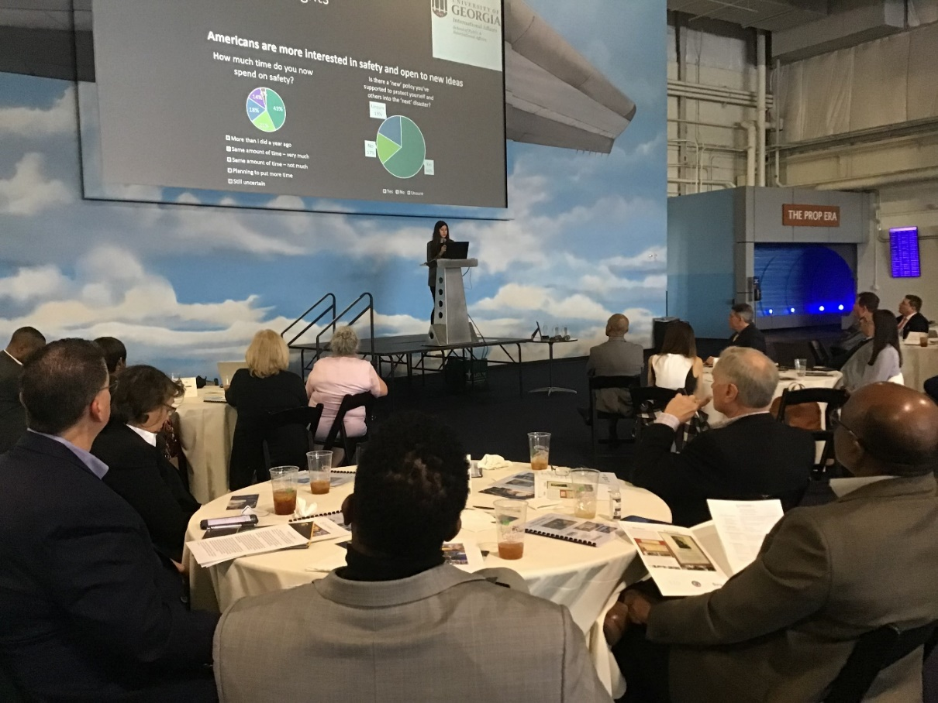



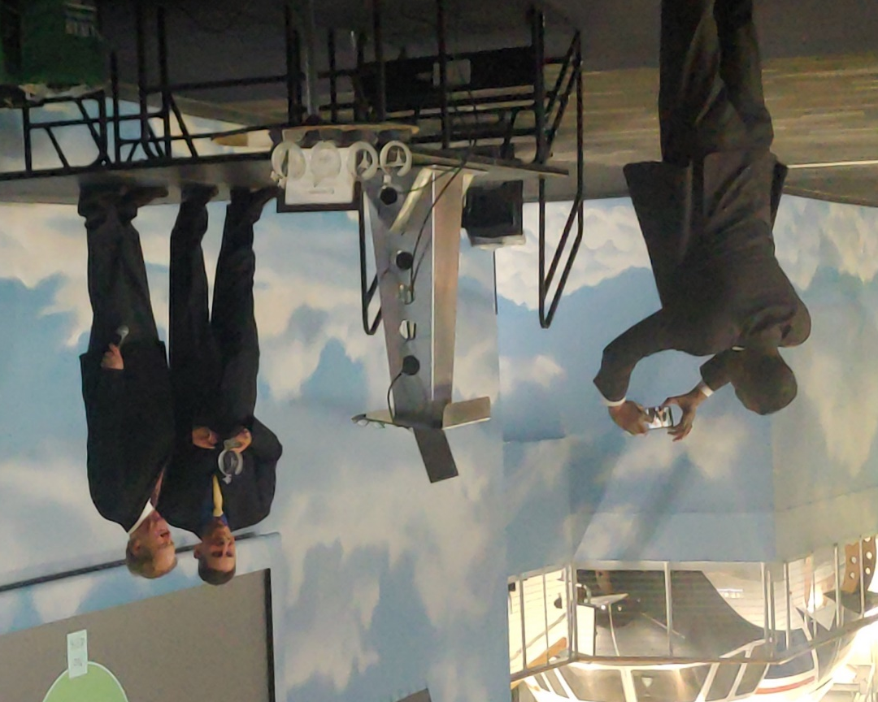

2022 Award Winners
@ Delta Flight Museum
December 7, 2021
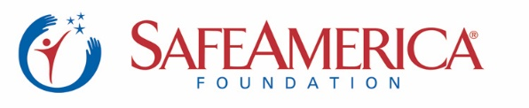

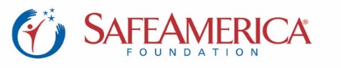
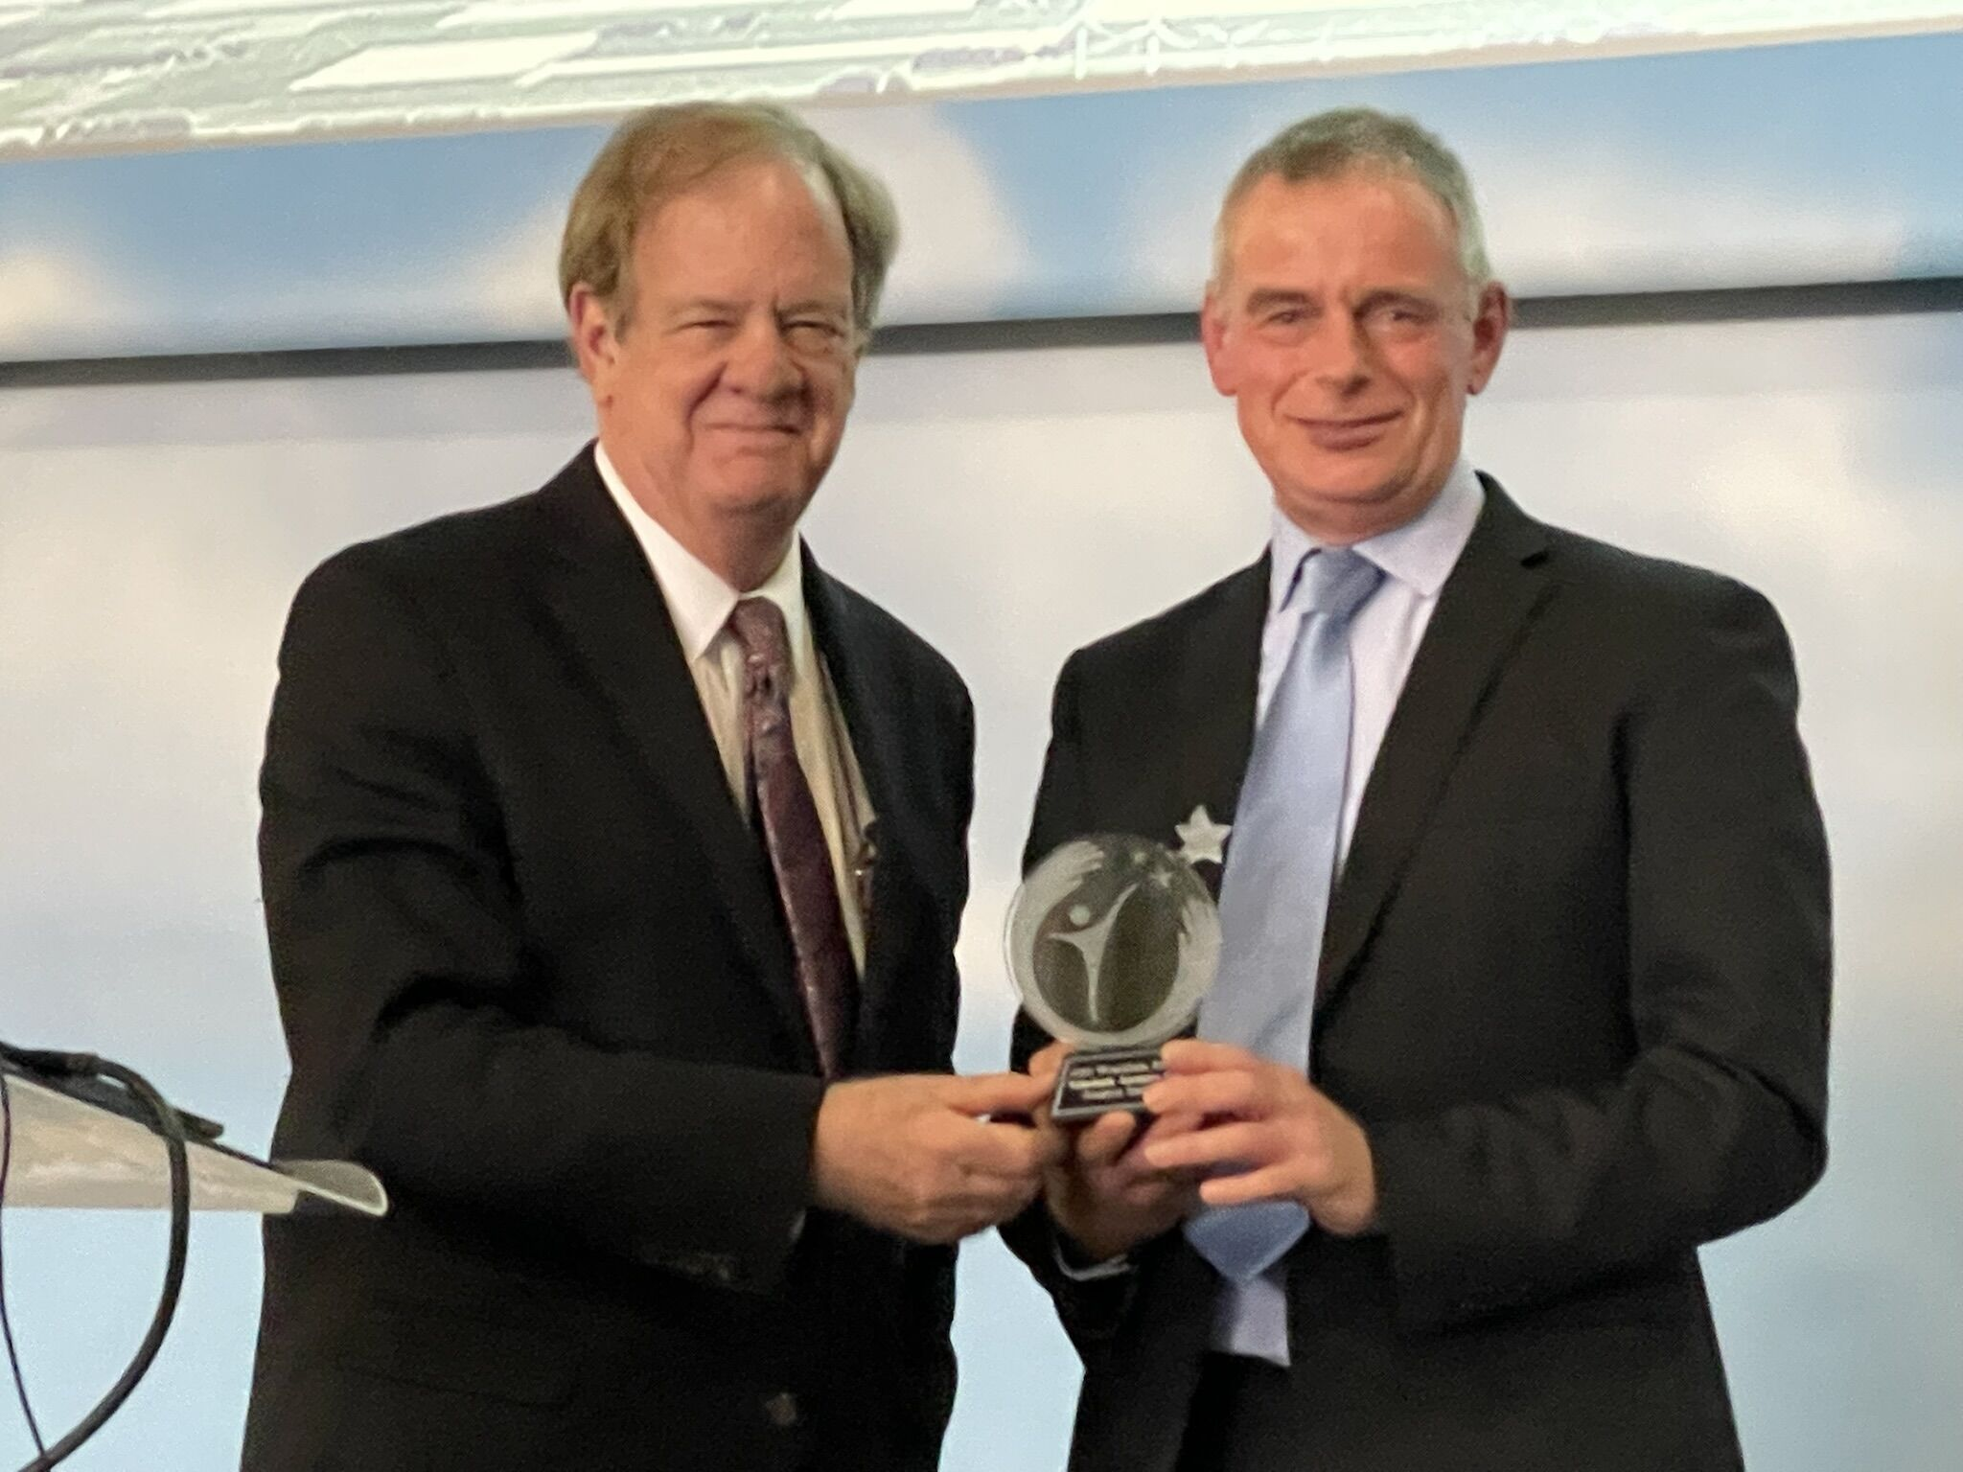

Henk Hesselink – Netherlands Aerospace Centre
2022 WorldSafe Award
For Developing Futuristic (Safe) Transportation with Circular Runways
and Safe Emergency/Disasters Shipments with Drones
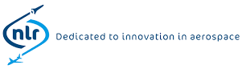
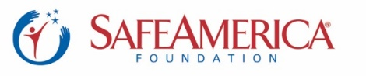
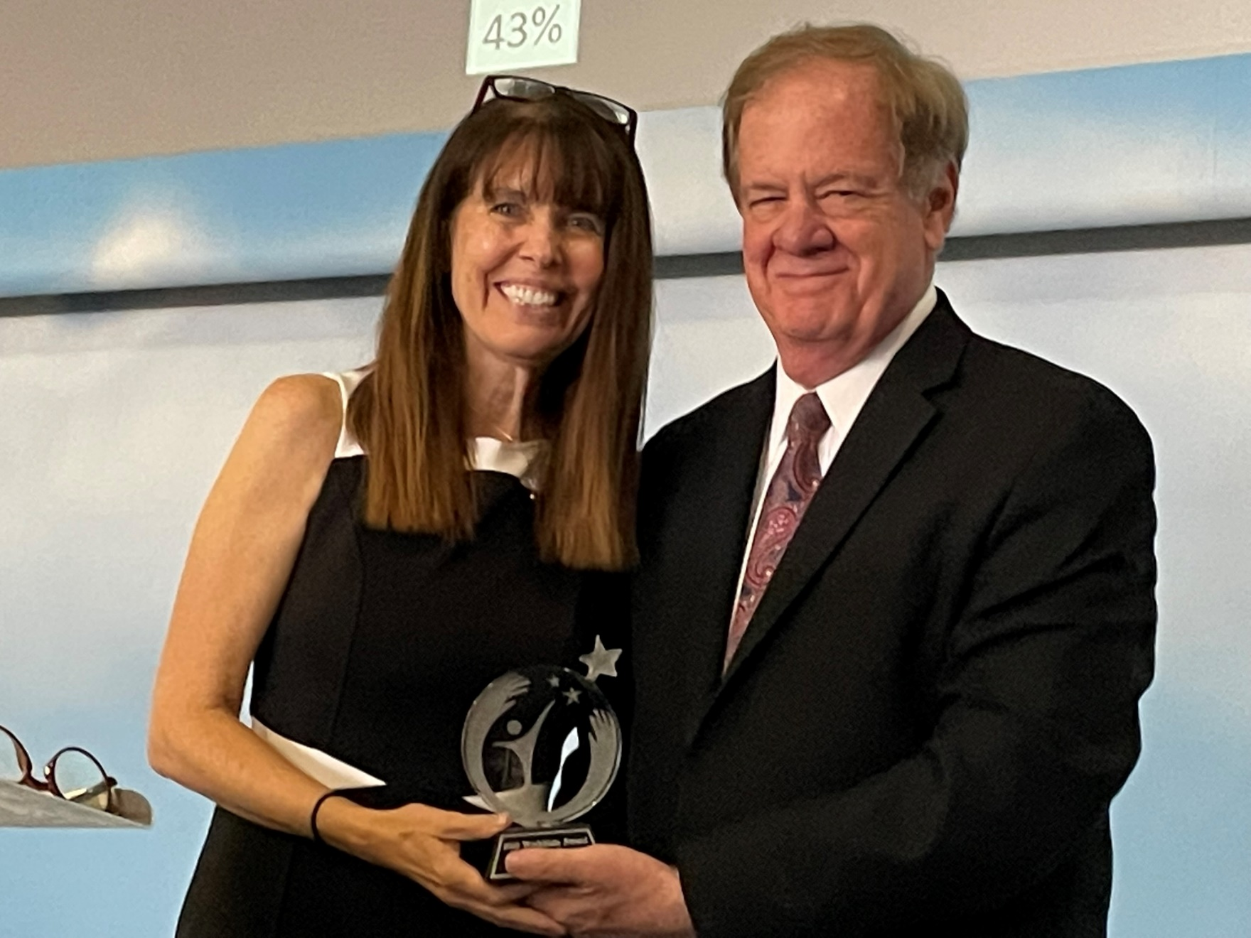
Suzanne Guy – Executive Director, 40 Days for Life
2022 Lifesaver Award / from WorldSafe Institute & Safe America Foundation
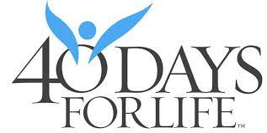
for Promoting Delivery of All Babies

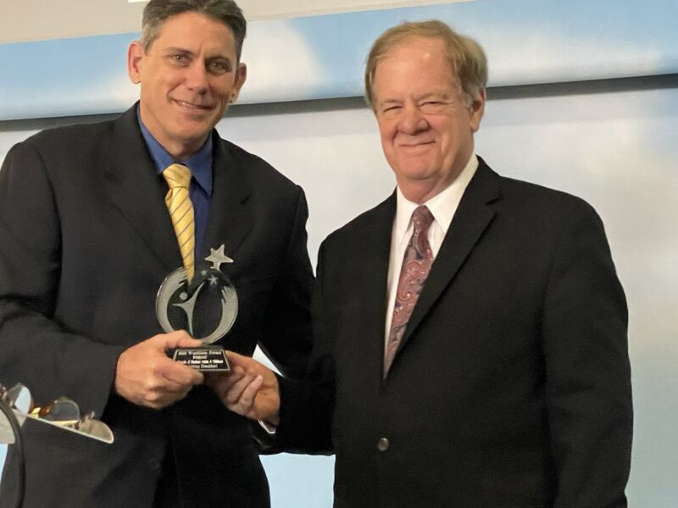

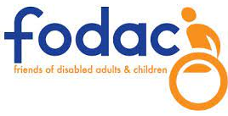
Chris Brand, FODAC
2022 Non-Profit CEO of the Year

for helping Disabled Adults and Children Who Could Not Walk
(and Mr. Brand donated 10,000 wheelchairs nationwide)

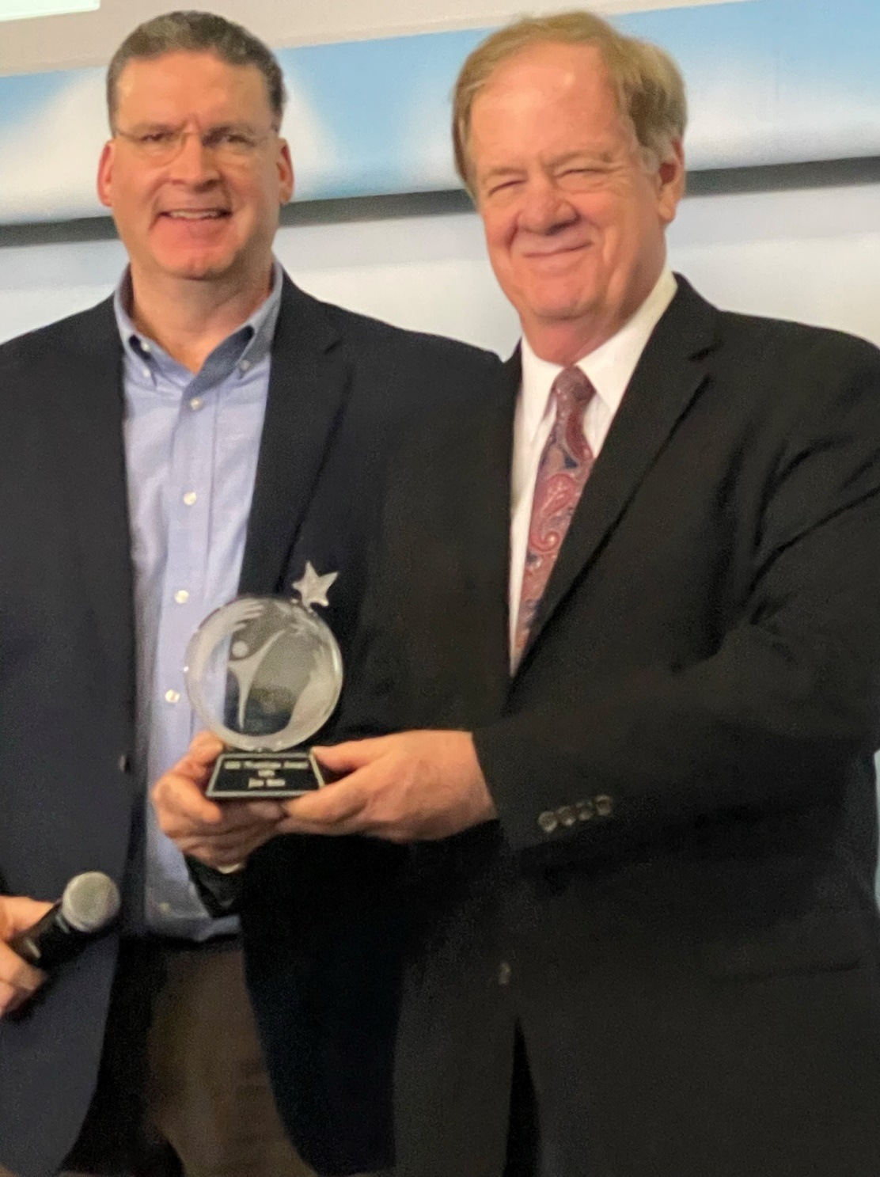

Joe Ruiz, Vice President
UPS Foundation
for significant work to transport millions
of masks and vaccines globally
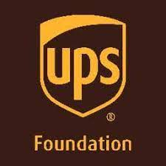
in 2022
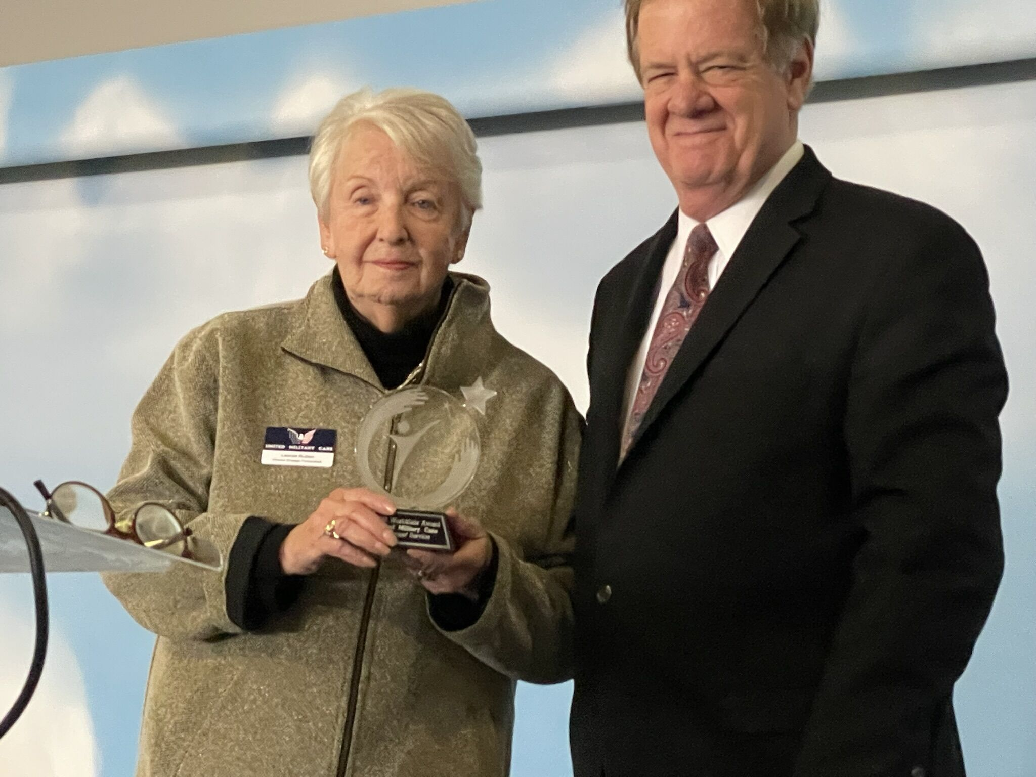

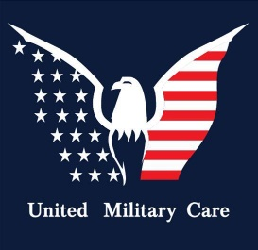
2022 Leadership Award for Veterans
United Military Care with Kim Scofi, CEO and Leenie Ruben, accepting the Award
For helping veterans who suffered in Afghanistan

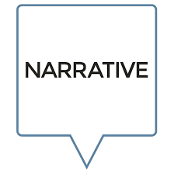
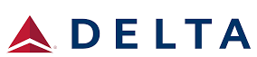
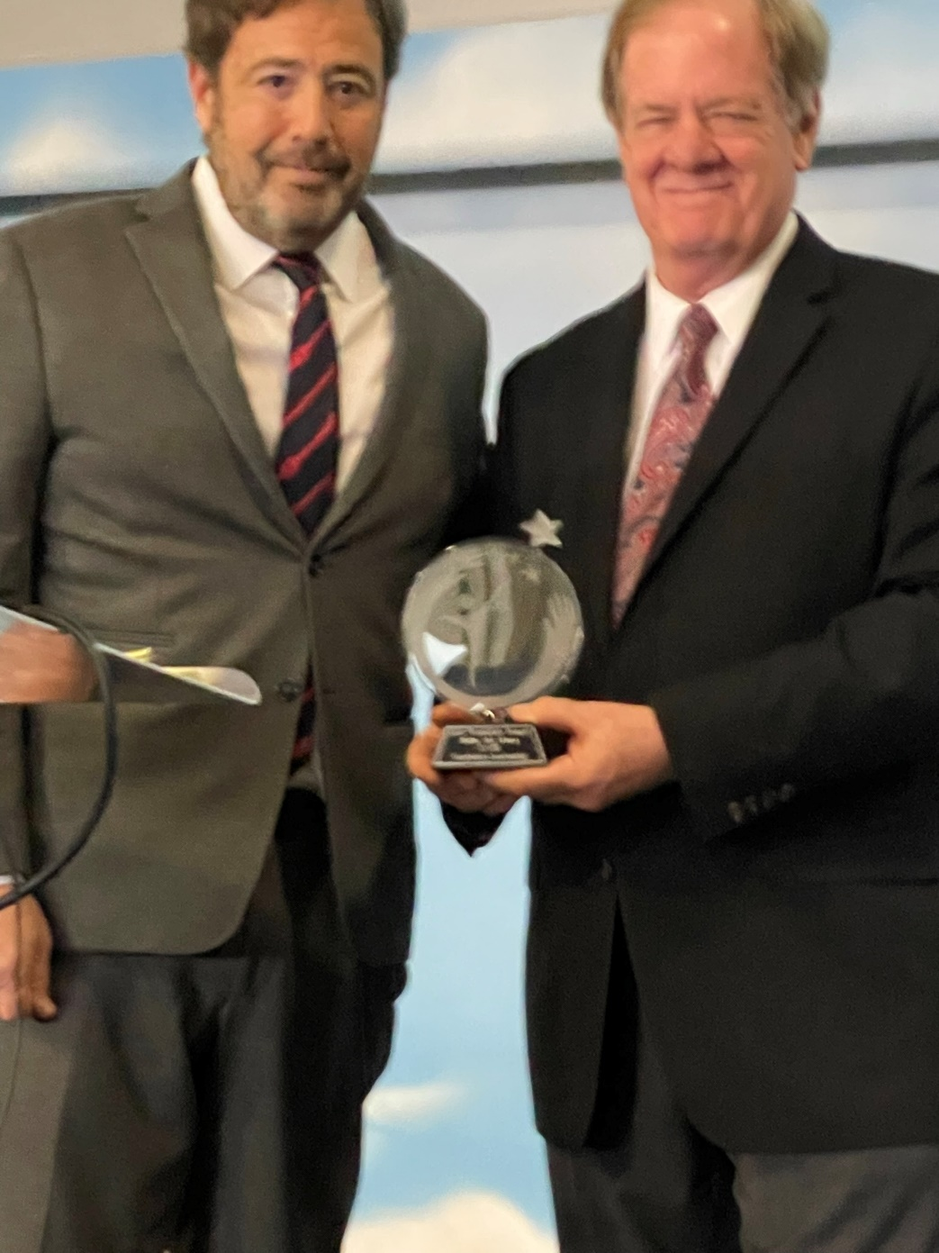
Delta Air Lines
& Narrative Content Group

for the Joint Initiative to Help Resolve COVID
via social media & Transporting Millions of Masks
across the USA and globally in 2021
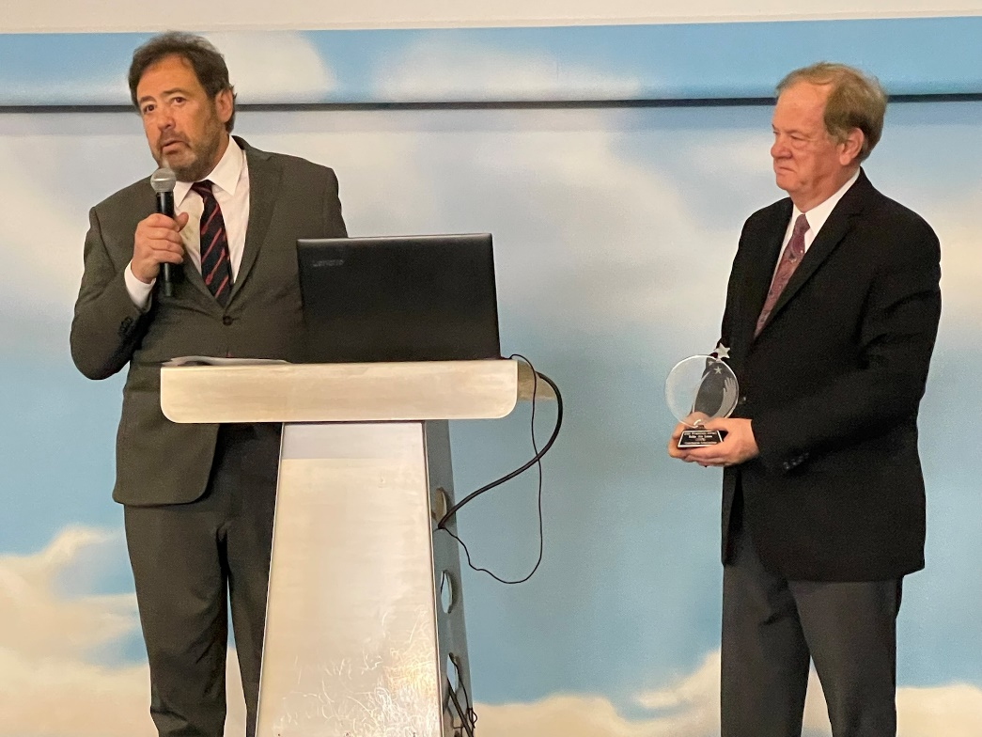
Accepted by Joel Babbit, CEO, Narrative Content Group

